**Java Dates SFD**

1. Liste déroulante 1

1.1. Format des Dates 1

2. JTabbedPane 3

3. Links 6

# Format des dates

## Class SimpleDateFormat

<https://docs.oracle.com/javase/7/docs/api/java/text/SimpleDateFormat.html>

|  |  |  |  |
| --- | --- | --- | --- |
| **Letter** | **Date or Time Component** | **Presentation** | **Examples** |
| G | Era designator | [Text](https://docs.oracle.com/javase/7/docs/api/java/text/SimpleDateFormat.html#text) | AD |
| y | Year | [Year](https://docs.oracle.com/javase/7/docs/api/java/text/SimpleDateFormat.html#year) | 1996; 96 |
| Y | Week year | [Year](https://docs.oracle.com/javase/7/docs/api/java/text/SimpleDateFormat.html#year) | 2009; 09 |
| M | Month in year | [Month](https://docs.oracle.com/javase/7/docs/api/java/text/SimpleDateFormat.html#month) | July; Jul; 07 |
| w | Week in year | [Number](https://docs.oracle.com/javase/7/docs/api/java/text/SimpleDateFormat.html#number) | 27 |
| W | Week in month | [Number](https://docs.oracle.com/javase/7/docs/api/java/text/SimpleDateFormat.html#number) | 2 |
| D | Day in year | [Number](https://docs.oracle.com/javase/7/docs/api/java/text/SimpleDateFormat.html#number) | 189 |
| d | Day in month | [Number](https://docs.oracle.com/javase/7/docs/api/java/text/SimpleDateFormat.html#number) | 10 |
| F | Day of week in month | [Number](https://docs.oracle.com/javase/7/docs/api/java/text/SimpleDateFormat.html#number) | 2 |
| E | Day name in week | [Text](https://docs.oracle.com/javase/7/docs/api/java/text/SimpleDateFormat.html#text) | Tuesday; Tue |
| u | Day number of week (1 = Monday, ..., 7 = Sunday) | [Number](https://docs.oracle.com/javase/7/docs/api/java/text/SimpleDateFormat.html#number) | 1 |
| a | Am/pm marker | [Text](https://docs.oracle.com/javase/7/docs/api/java/text/SimpleDateFormat.html#text) | PM |
| H | Hour in day (0-23) | [Number](https://docs.oracle.com/javase/7/docs/api/java/text/SimpleDateFormat.html#number) | 0 |
| k | Hour in day (1-24) | [Number](https://docs.oracle.com/javase/7/docs/api/java/text/SimpleDateFormat.html#number) | 24 |
| K | Hour in am/pm (0-11) | [Number](https://docs.oracle.com/javase/7/docs/api/java/text/SimpleDateFormat.html#number) | 0 |
| h | Hour in am/pm (1-12) | [Number](https://docs.oracle.com/javase/7/docs/api/java/text/SimpleDateFormat.html#number) | 12 |
| m | Minute in hour | [Number](https://docs.oracle.com/javase/7/docs/api/java/text/SimpleDateFormat.html#number) | 30 |
| s | Second in minute | [Number](https://docs.oracle.com/javase/7/docs/api/java/text/SimpleDateFormat.html#number) | 55 |
| S | Millisecond | [Number](https://docs.oracle.com/javase/7/docs/api/java/text/SimpleDateFormat.html#number) | 978 |
| z | Time zone | [General time zone](https://docs.oracle.com/javase/7/docs/api/java/text/SimpleDateFormat.html#timezone) | Pacific Standard Time; PST; GMT-08:00 |
| Z | Time zone | [RFC 822 time zone](https://docs.oracle.com/javase/7/docs/api/java/text/SimpleDateFormat.html#rfc822timezone) | -0800 |
| X | Time zone | [ISO 8601 time zone](https://docs.oracle.com/javase/7/docs/api/java/text/SimpleDateFormat.html#iso8601timezone) | -08; -0800; -08:00 |

# Liste déroulante

## Format des Dates

TU

eu

usa

uk

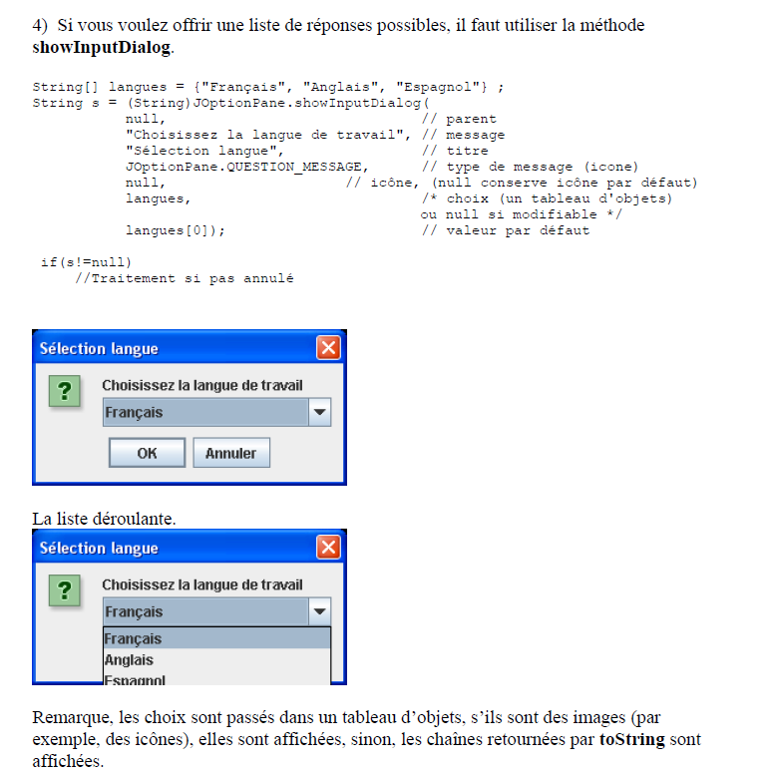

C:\Users\Djamel\Workspace\jSwing\JOptionPane\JOptionPane\WorkItems

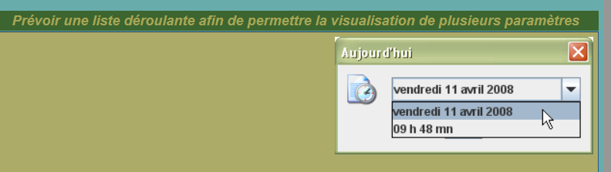

<http://remy-manu.no-ip.biz/Java/Tutoriels/IHM/dialogue.html>

# JTabbedPane

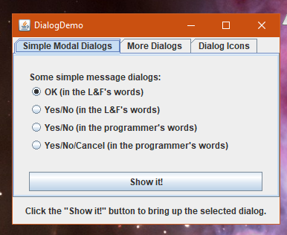

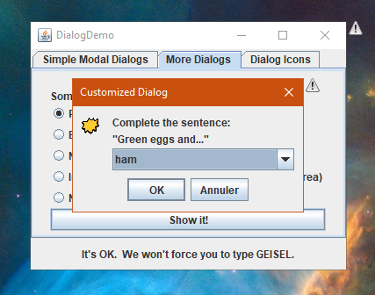

# Links

<https://www.delftstack.com/fr/howto/java/how-to-get-the-current-date-time-in-java/>

<https://docs.oracle.com/javase/8/docs/api/java/time/format/DateTimeFormatter.html>

<https://www.delftstack.com/fr/howto/java/java-get-current-timestamp/>

<https://koor.fr/Java/API/java/lang/System/currentTimeMillis.wp>